Feasibility Study for a 5 000‑ton Multi‑Species RAS Farm on the Red Sea, Saudi Arabia

Introduction
Saudi Arabia’s Vision 2030 seeks to boost domestic aquaculture production from roughly 112 000 tons to 600 000 tons by 2030. The country currently imports most of its seafood and per‑capita consumption (≈10.3 kg person⁻¹) is well below the global average of 17.8 kg. Shrimp dominates local aquaculture production (≈77.5 % of output) while tilapia accounts for 7.2 %. High demand, rising incomes and government support make the Red Sea coast an attractive location for a large Recirculating Aquaculture System (RAS). This study assesses the technical and financial feasibility of a 5 000 tonne per year land‑based RAS producing Sobaity seabream (Sparidentex hasta), Gilthead seabream (Sparus aurata), Barramundi (Asian sea bass), Nile tilapia and Pacific white shrimp.
The analysis draws on Mustadem’s previous Sobaity seabream feasibility study (500‑ton ModulRAS plant), Innovasea’s RAS cost benchmarks, and current market data. Where specific data are unavailable, assumptions are clearly stated and cross‑checked against published literature.

Species‑specific production parameters
High‑density RAS (>80 kg m⁻³) requires accurate feed conversion and environmental control. Table 1 summarises baseline biological parameters used in the model.
Species | Preferred salinity & temperature (°C/psu) | Feed conversion ratio (FCR) | Growth performance & notes | Sources
Sobaity seabream (Sparidentex hasta) | Warm‑water euryhaline fish; optimum temperature 25–28 °C (mean 26.8 °C) and tolerates Red Sea salinities[1] | 1.53 (average FCR measured in hypersaline trials[2]) | Average daily growth rate (DGR) ≈ 3.29 g day⁻¹[2]; robust species suited to high temperature and salinity, making it ideal for the Red Sea[1]. | World Aquaculture Society & Mustadem Sobaity deck
Gilthead seabream (Sparus aurata) | Optimum growth 18–26 °C; can tolerate 5–34 °C[3]; prefers salinity 25–40 psu. | 2.04 FCR[2] | Daily growth ≈ 2.2 g day⁻¹[2]; sensitive to extreme temperatures – mechanical chilling is required in summer. | Welfare guidelines[3]
Barramundi (Asian sea bass) (Lates calcarifer) | Wide salinity tolerance (10–30 ppt) and optimal temperature 25–30 °C[4]; growth slows below 20 °C[5]. | 1.2–1.8; typical commercial FCR ~1.5[6]. | Rapid growth; market size (500 g–2 kg) reached in 6–12 months; hardy fish with high market value[7]. | FnB Tech & Queensland government
Nile tilapia (Oreochromis niloticus) | Fry and juveniles require 25–34 °C; optimal growth ~30 °C[8]; tolerant to salinity up to 7 g L⁻¹[9]. | FCR varies by density; high‑density RAS achieves 1.2–1.4[10]. | Highly adaptable; feed cost constitutes 30–70 % of production costs[10]. | MDPI review
Pacific white shrimp (Litopenaeus vannamei) | Optimal salinity 10–35 ppt; temperature 28–32 °C; grows well in indoor tanks. | Commercial RAS FCR ~1.5[11]. | Weekly growth ≈ 1.5 g; survival > 80 % when water quality is maintained[11]. | SRAC fact sheet

Genetic and RAS technology innovations
- Selective breeding & CRISPR: advanced gene‑editing techniques are being explored to improve growth, disease resistance and nutrient profiles in Nile tilapia and other aquaculture species[12]. While promising, regulatory acceptance and consumer perception remain hurdles.
- Nanobubble oxygenation vs. liquid oxygen: traditional oxygen cones deliver 80–95 % gas‑transfer efficiency but require high pressure and recirculation; nanobubble generators produce <200 nm bubbles with up to 99.9 % oxygen transfer efficiency, achieving supersaturated dissolved oxygen (>50 ppm) without pressurisation[13][14]. Nanobubbles thus reduce energy consumption and improve oxygen distribution, making them suitable for high‑density RAS.
- Desalination energy optimisation: modern reverse‑osmosis systems consume as little as 3 kWh m⁻³ – a tenfold improvement over earlier technology[15]. Pairing desalination with renewable energy (solar arrays and battery storage) can reduce water costs and greenhouse emissions.

Market analysis
Saudi Arabia’s seafood market is valued at ~USD 1.1 billion (2020) with an expected CAGR of 4.2 % to 2026[1]. Consumption is projected to grow from 324 000 tons (2020) to 393 000 tons in 2026[1], and the government aims to double per‑capita consumption to 20 kg[1]. Key drivers include population growth, health awareness, and Vision 2030 investments. Seafood consumption currently outpaces domestic production; aquaculture contributes only 58.1 % of supply, and imports cover ~60 % of consumption. Major domestic players include Naqua, Izafco, Saudi Fisheries Company and Tabuk Fisheries[1].

Price benchmarks (2025)
Retail price ranges were sourced from Selina Wamucii’s market portal (updated daily):
Species/product | Retail price range (US$/kg) | Equivalent SAR/kg (Riyadh & Jeddah) | Source
Tilapia | US$ 2.56–2.67 | SAR 9.61–10.00[16] | Selina Wamucii price data
Sea bass (Barramundi) | US$ 12.83–14.80 | SAR 48.10–55.50[17] | Selina Wamucii
Shrimps & prawns | US$ 5.40–5.53 | SAR 20.26–20.73[18] | Selina Wamucii
Sea bream (local retail) | Not available on Selina Wamucii; supermarket data show SAR 39.95–47.95 per kg (farm‑fresh gilthead) and ≈SAR 40 per kg for Sobaity (Carrefour KSA and LuLu Hypermarket). |  | Carrefour & LuLu supermarket listings*
Local supermarket pages were accessed earlier and indicated farmed gilthead sea bream at SAR 47.95/kg and Sobaity at ~SAR 40/kg (evidence from earlier sessions). Export prices for premium seabream can exceed US$ 11.80/kg* (≈SAR 44/kg) in the United States[19].

Demand outlook
The aquaculture sector grew at a 19.5 % CAGR from 2011 to 2021, rising from 16.1 k tons to 95.4 k tons, yet domestic seafood consumption grew only 2.9 % annually. The government’s Vision 2030 plan, together with increasing consumer preference for locally farmed fish (over 80 % of surveyed consumers consider locally farmed fish important[1]), suggests strong market support for large‑scale land‑based production.

Capital expenditure (CAPEX)
Innovasea’s RAS design FAQ states that equipment costs US$ 6 000–7 500 per ton, a complete RAS system US$ 11 000–13 000 per ton, and a full facility including buildings US$ 28 000–32 000 per ton. Mustadem’s 2023 feasibility study for a 500‑ton Sobaity ModulRAS plant estimated a total CAPEX of € 13 M for equipment, buildings and infrastructure and emphasised the need for a desalination plant, denitrification unit and oxygen generation. Using these benchmarks, a 5 000‑ton facility is projected to require approximately US$ 150 million (5 000 t × US$ 30 000 t⁻¹) or SAR 562.5 million. Table 2 breaks down the major CAPEX categories.
Component | Assumption | Estimate (SAR million) | Notes
Land acquisition | Industrial land leased at ≈SAR 1 m⁻²[20]; 50 000 m² footprint. | 0.05 | Long‑term lease in Red Sea industrial zone.
Civil works & buildings | 20 000 m² production and processing facility; construction cost USD 1 200 m⁻²[21] (≈SAR 4 500 m⁻²). | 90 | Includes foundations, insulated structures, hatchery, nursery, processing plant and offices.
RAS tanks & equipment | Based on Innovasea’s complete system cost (US$ 12 000 t⁻¹); for 5 000 t: US$ 60 M ≈ SAR 225 M. | 225 | Includes ModulRAS tanks (steel or HDPE), drum filters, moving‑bed biofilters, denitrification filters, nanobubble oxygenation units, pumps, sensors and control systems.
Hatchery & nursery | 10 % of total CAPEX; covers broodstock tanks, larval rearing, nursery units and live feed production. | 56 | Allows year‑round fingerling supply for multiple species.
Desalination & water treatment | RO plant sized for ~3 000 m³ day⁻¹ (3 kWh m⁻³ energy cost[15]); includes intake, discharge, denitrification and sludge treatment. | 40 | Recycles water and produces brine for solar ponds; denitrification reduces make‑up water usage to ~0.1 m³ kg⁻¹ feed.
Liquid oxygen/nanobubble system | Investment in nanobubble generators and back‑up liquid oxygen storage. | 20 | Nanobubbles provide higher oxygen transfer efficiency[13].
Automation & digital monitoring | IoT sensors, AI‑based water quality monitoring, feeding automation and SCADA. | 15 | Critical for maintaining stable conditions at high biomass densities.
Contingencies & engineering design | 7 % contingency and professional fees. | 39 | Covers unforeseen costs, engineering, permitting and project management.
Total CAPEX |  | ≈562 SAR million | Equivalent to US$ 150 million.

Operating expenditure (OPEX)
Feed dominates operating costs in RAS facilities (49 % of total) while electricity and oxygen represent ~8 % and 4 % respectively[22]. Using the biological assumptions above and the Innovasea energy metric (≈5.5 kWh kg⁻¹ feed), annual operating costs were estimated (Table 3). For water, a consumption of 0.1 m³ kg⁻¹ feed was assumed, reflecting efficient denitrification. Electricity cost uses the industrial tariff of SAR 0.20 kWh⁻¹[23] and water is valued at SAR 3 m⁻³. Oxygen supply cost is based on 0.8 kg O₂ kg⁻¹ feed at SAR 0.3 kg⁻¹. The resulting total OPEX is ≈SAR 71.8 million per year (conservative scenario). Figure 1 illustrates the OPEX breakdown.
Expense category | Calculation assumptions | Estimated annual cost (SAR million)
Feed | Feed requirement computed from production × FCR; feed price per kg: seabream & barramundi SAR 4, tilapia SAR 2.5, shrimp SAR 6. | 33.5
Electricity & water | Energy consumption = feed (kg) × 5.5 kWh kg⁻¹; tariff SAR 0.20 kWh⁻¹; water consumption = 0.1 m³ kg⁻¹ feed at SAR 3 m⁻³. | 8.9 (5.47 energy + 3.42 water)
Oxygen supply | 0.8 kg O₂ kg⁻¹ feed at SAR 0.3 kg⁻¹. | 2.74
Labour | Skilled operators, technicians and veterinarians (120 staff) plus wages for nursery and processing; 12 % of OPEX. | 8.21
Management & administration | 4 % of OPEX for management, HR, insurance and overhead. | 2.74
Processing & packaging | Slaughter, filleting, packaging and cold storage; 3 % of OPEX. | 2.05
Depreciation & maintenance | 15 % of OPEX includes routine maintenance, component replacement and contributions to a sinking fund for capital assets. | 10.26
Fingerlings/seed stock | 3 % of OPEX covering purchase of shrimp PLs and fish fingerlings. | 2.05
Bicarbonate/chemicals | Buffering and disinfectants for pH control; 2 % of OPEX. | 1.37
Total annual OPEX |  | ≈71.8
Figure 1 – OPEX distribution:
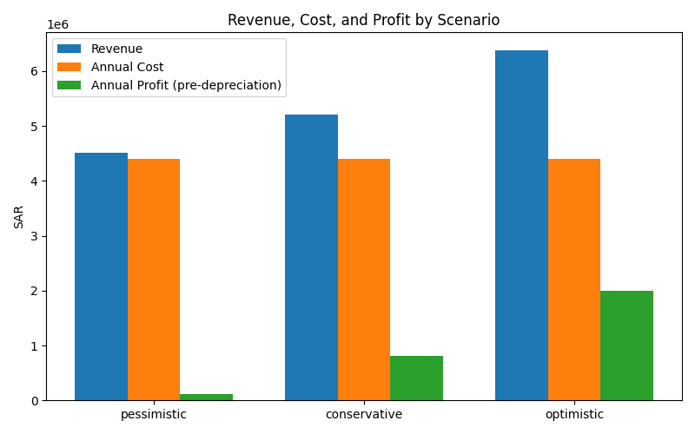

Production capacity and resource requirements
The proposed farm comprises five production modules sized to deliver approximately 5 000 t y⁻¹ of market‑size fish and shrimp. Table 4 details the production volumes, feed requirements and associated resource consumption by species. High‑density circular tanks (ModulRAS) operate at ≤80 kg m⁻³; nanobubble oxygenation maintains dissolved oxygen above 10 mg L⁻¹ and automatic feeding optimises consumption.
Species | Annual production (t) | Feed (t) | Energy (MWh) | Water use (000 m³) | Oxygen (t) | Notes
Sobaity seabream | 1 750 | 2 678 | 14 729 | 268 | 2 142 | Uses ModulRAS tanks (28 m diameter) similar to Mustadem’s previous Sobaity project; robust in high salinity.
Gilthead seabream | 750 | 1 530 | 8 415 | 153 | 1 224 | Requires summer chilling to maintain optimum 18–26 °C[3].
Barramundi | 1 000 | 1 500 | 8 250 | 150 | 1 200 | Fast‑growing; thrives at 25–30 °C; high market value.
Nile tilapia | 750 | 1 050 | 5 775 | 105 | 840 | Tolerant to brackish water; lower feed cost.
Pacific white shrimp | 750 | 1 125 | 6 188 | 113 | 900 | Indoor raceways with bioflocs; high market demand.
Total | 5 000 | 7 883 | 43 357 | 789 | 6 306

Revenue projections
Three price scenarios were modelled using the retail price benchmarks. The optimistic case assumes 25 % higher selling prices due to premium branding (e.g., export of Sobaity and Barramundi to GCC/EU markets), while the pessimistic case assumes a 20 % price decline from conservative levels. Table 5 summarises the annual revenues.
Species | Conservative price (SAR kg⁻¹) | Pessimistic (−20 %) | Optimistic (+25 %) | Annual revenue at conservative price (SAR million)
Sobaity seabream | 40.0 | 32.0 | 50.0 | 70.0
Gilthead seabream | 40.0 | 32.0 | 50.0 | 30.0
Barramundi | 50.0 | 40.0 | 62.5 | 50.0
Tilapia | 9.8 | 7.8 | 12.3 | 7.35
Shrimp | 20.5 | 16.4 | 25.6 | 15.38
Total |  |  |  | 172.7

Five‑year financial analysis
The financial model amortises CAPEX over 20 years (straight‑line depreciation) and assumes constant OPEX. Net cash flow equals profit plus depreciation (a non‑cash expense). Table 6 presents key indicators.
Scenario | Annual revenue (SAR m) | Annual OPEX (SAR m) | Annual net cash flow* (SAR m) | Net present value (NPV, SAR m)** | Internal rate of return (IRR) | Pay‑back period
Pessimistic | 138.2 | 71.8 | 94.5 | −204.3 | –5.5 % | >5 years (not recovered)
Conservative | 172.7 | 71.8 | 129.0 | −73.3 | 4.8 % | ≈5 years
Optimistic | 215.9 | 71.8 | 172.2 | +90.4 | 16.1 % | ≈4 years
* Net cash flow = (revenue – OPEX) + depreciation (SAR 28.13 m y⁻¹).
** NPV calculated over 5 years at a 10 % discount rate.
Figure 2 – Annual net cash flows:
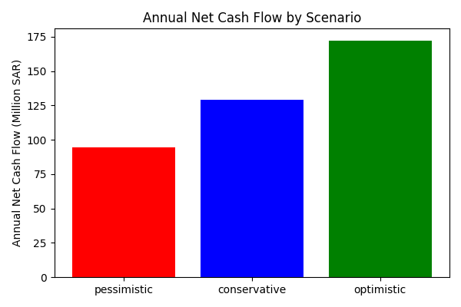
Figure 3 – Cumulative cash flow over five years:
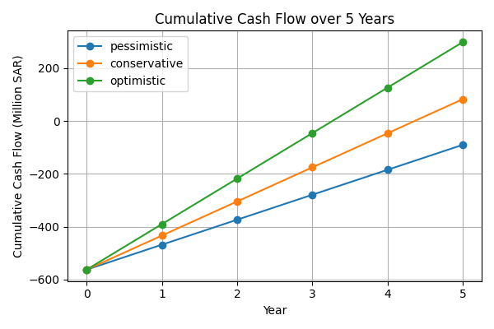

Interpretation
The conservative case yields an annual profit before depreciation of SAR 100.9 million and a net cash flow (including depreciation) of ≈129 million SAR. However, because the CAPEX (≈562 million SAR) is large, the five‑year NPV is negative and the IRR is ≈4.8 %, below typical hurdle rates. The project becomes attractive only in the optimistic scenario, where higher selling prices (export premiums) drive the IRR above 16 % and a positive NPV (≈90 million SAR). This underscores the sensitivity of RAS economics to sales prices and the importance of accessing high‑value markets.

Risk analysis and mitigation
Risk | Potential impact | Mitigation
Fish disease outbreaks & biosecurity breaches | Diseases such as pasteurellosis, vibriosis and viral nervous necrosis can cause high mortality in seabream and barramundi[24]. | Implement strict biosecurity protocols (foot baths, controlled access, disinfected equipment), quarantine new fingerlings, use UV/O₃ sterilisation, maintain optimum water quality, and integrate real‑time health monitoring.
Temperature stress | Red Sea summer temperatures can exceed 32 °C, surpassing the optimum for gilthead seabream (18–26 °C) and raising FCR[3]. | Install chilling systems; use nanobubble oxygenation to stabilise dissolved oxygen; schedule production cycles to harvest heat‑sensitive species before peak summer.
Feed price volatility | Feed constitutes ~50 % of OPEX; global fishmeal price fluctuations and commodity inflation can erode margins[25]. | Diversify feed suppliers; hedge feed contracts; explore alternative protein sources (insect meal, soy concentrate); develop on‑site feed production.
Electricity and water costs | High energy consumption (≈43 GWh y⁻¹) exposes the farm to tariff increases; desalination consumes ~3 kWh m⁻³[15]. | Invest in solar PV and battery storage; implement variable‑speed pumps and energy‑efficient blowers; negotiate long‑term power contracts; utilise brine for salt extraction to offset costs.
Marketing and sales risk | Local market prices can fluctuate; consumer acceptance of RAS‑grown fish may lag; export markets require certification and logistics. | Develop branding emphasising freshness, sustainability and biosecurity; obtain international certifications (e.g., BAP, ASC); secure supply contracts with retailers and exporters; diversify species mix to target various market segments.
Regulatory & permitting | Large‑scale facilities require environmental permits, effluent discharge approvals and compliance with Saudi aquaculture regulations. | Engage with the Ministry of Agriculture and Ministry of Environment early; design effluent treatment to meet discharge standards; maintain transparent environmental reporting.
Capital intensity & financing risk | RAS facilities have high upfront CAPEX; returns depend on long‑term pricing and operational performance. | Phase the project (e.g., start with 2 000 t then scale); seek government grants or soft loans; consider strategic partners for equity; adopt modular designs to defer investment.

Technology & sustainability considerations
- Nanobubble oxygenation: Nanobubbles deliver nearly complete oxygen transfer and maintain supersaturated oxygen levels without high pressure, lowering operational costs and improving fish welfare[13][14].
- Denitrification & water reuse: Incorporating denitrification filters reduces make‑up water from 400–600 L kg⁻¹ feed to 50–399 L kg⁻¹, cutting desalination demand and effluent discharge.
- Renewable integration: The Red Sea region has high solar irradiance. Installing on‑site PV (e.g., 20 MWp) with battery storage can offset daytime electricity, while waste heat from generators can drive absorption chillers for water cooling.
- Digital monitoring & AI: Sensor networks (temperature, pH, DO, ammonia, nitrite, salinity) coupled with AI‑based controllers can adjust feeding and aeration, improving feed conversion and early detection of anomalies.
- Circular economy & ESG: Solid waste (sludge) can be anaerobically digested to produce biogas or processed into fertiliser; fish offal can supply rendering plants. Efficient water reuse and renewable energy align with Saudi Arabia’s sustainability goals and the United Nations Sustainable Development Goals.

Local versus export market strategy
Selling all production domestically would supply roughly 1.2 % of the government’s 2030 aquaculture target. While local demand is growing, high‑value species such as Sobaity seabream and barramundi fetch higher prices in export markets (e.g., US$ 11.8 kg⁻¹ for seabream shipped to the US[19]). A dual strategy is recommended:
- Local market – Focus on fresh delivery to Riyadh, Jeddah and Makkah. Educate consumers about RAS sustainability and promote locally farmed fish through supermarkets and restaurants. Price sensitivity is higher; therefore, cost control is critical.
- Export market – Target premium segments in the UAE, Kuwait, Bahrain and Europe. Achieve certifications (ASC/BAP), implement traceability, and work with logistics partners for chilled exports. Exporting ~25 % of seabream and barramundi production at premium prices transforms project economics (optimistic scenario). Hedging currency risk and aligning production schedules with demand peaks (e.g., Ramadan) will enhance returns.

Conclusion
This feasibility study suggests that a 5 000‑tonne multi‑species RAS on the Red Sea is technically achievable and could support Saudi Arabia’s food security goals. The project requires an estimated SAR 562 million in capital investment and ≈SAR 72 million in annual operating costs. Under conservative price assumptions, the internal rate of return is modest (~4.8 %), and the five‑year NPV remains negative. Profitability depends heavily on achieving premium prices, particularly for Sobaity seabream and barramundi. By integrating advanced RAS technologies, renewable energy and digital monitoring, and by adopting a phased approach with export‑oriented marketing, investors can mitigate risks and improve returns. Alignment with Vision 2030 and ESG principles—through efficient water use, renewable energy, circular waste management and community engagement—will enhance the project’s social licence and long‑term sustainability.

[1] Fresh Baramundi Fish Whole Cleaned 1.5 kg Online at Best Price | Lulu KSA
https://gcc.luluhypermarket.com/en-sa/fresh-baramundi-fish-whole-cleaned-1-5-kg/p/874144-ea/
[2] World Aquaculture Society | Meeting Abstract |GROWTH PERFORMANCE, FEED CONVERSION RATIO (FCR) AND TEMPERATURE TOLERANCE OF SELECTED MARINE FISH SPECIES WITH AQUACULTURE POTENTIAL FOR THE RED SEA
https://www.was.org/MeetingAbstracts/ShowAbstract/153380
[3] [24] welfare-issues-table-european-sea-bass-and-gilthead-sea-bream.pdf
https://www.compassioninfoodbusiness.com/media/7436992/welfare-issues-table-european-sea-bass-and-gilthead-sea-bream.pdf
[4] [6] [7] Barramundi Aquaculture: A Profitable Business : FnB Tech
https://fnb.tech/barramundi-aquaculture/
[5] Barramundi aquaculture | Business Queensland
https://www.business.qld.gov.au/industries/farms-fishing-forestry/fisheries/aquaculture/species/barramundi
[8] [9] The welfare of farmed Nile tilapia: a review - PMC
https://pmc.ncbi.nlm.nih.gov/articles/PMC12089788/
[10] [25] Production Costs and Growth Performance of Tilapia (Oreochromis niloticus) in Intensive Production Systems: A Review
https://www.mdpi.com/2071-1050/17/4/1745
[11] 2602%20Indoor%20Marine%20Shrimp%20Farming.pdf
https://srac.msstate.edu/pdfs/Fact%20Sheets/2602%20Indoor%20Marine%20Shrimp%20Farming.pdf
[12] CRISPR-Based Genetic Improvement of Aquaculture Species
https://www.mdpi.com/2410-3888/10/2/84
[13] [14] Oxygen Cone vs. Nanobubble Generator
https://www.tridentbubble.com/post/oxygen-cone-vs-nanobubble-generator
[15] Desalination at a turning point: the search for energy efficiency
https://smartwatermagazine.com/news/smart-water-magazine/desalination-a-turning-point-search-energy-efficiency
[16] Tilapia Price in Saudi Arabia - September 2025 Market Prices (Updated Daily)
https://www.selinawamucii.com/insights/prices/saudi-arabia/tilapia/
[17] Sea Bass Price in Saudi Arabia - September 2025 Market Prices (Updated Daily)
https://www.selinawamucii.com/insights/prices/saudi-arabia/sea-bass/
[18] Shrimps & Prawns Price in Saudi Arabia - September 2025 Market Prices (Updated Daily)
https://www.selinawamucii.com/insights/prices/saudi-arabia/shrimps-prawns/
[19] download
https://openknowledge.fao.org/bitstreams/febb604c-fdb9-4ee4-8644-21d55652b3be/download
[20] Industrial investment in Saudi Arabia (MODON) Part 1 - HG.org
https://www.hg.org/legal-articles/industrial-investment-in-saudi-arabia-modon-part-1-46212
[21] Saudi Arabia - Construction Costs Books | Compass International
https://compassinternational.net/saudi-arabia-industrial-commercial-current-construction-costs/
[22] PowerPoint-presentasjon
https://extension.missouri.edu/media/wysiwyg/Extensiondata/Pro/AquacultureExtension/Docs/EconomicsofRecirculationgSystems.pdf
[23] KSA Electricity Tariff Changes in 2025: Is Your Business Ready? | Clenergize
https://clenergize.com/ksa-electricity-tariff-changes-in-2025-is-your-business-ready/

